PROJECT—CYBER SECURITY INCIDENT TRACKER
BY —SHUBHAM SHARMA
R.NO-24BCY10391

- Get API
URL -http://localhost:3000/api/users
No json file
Response
[
{
"user_id": 1,
"name": "Shubham",
"email": "shubham@gmail.com",
"role": "Admin"
}
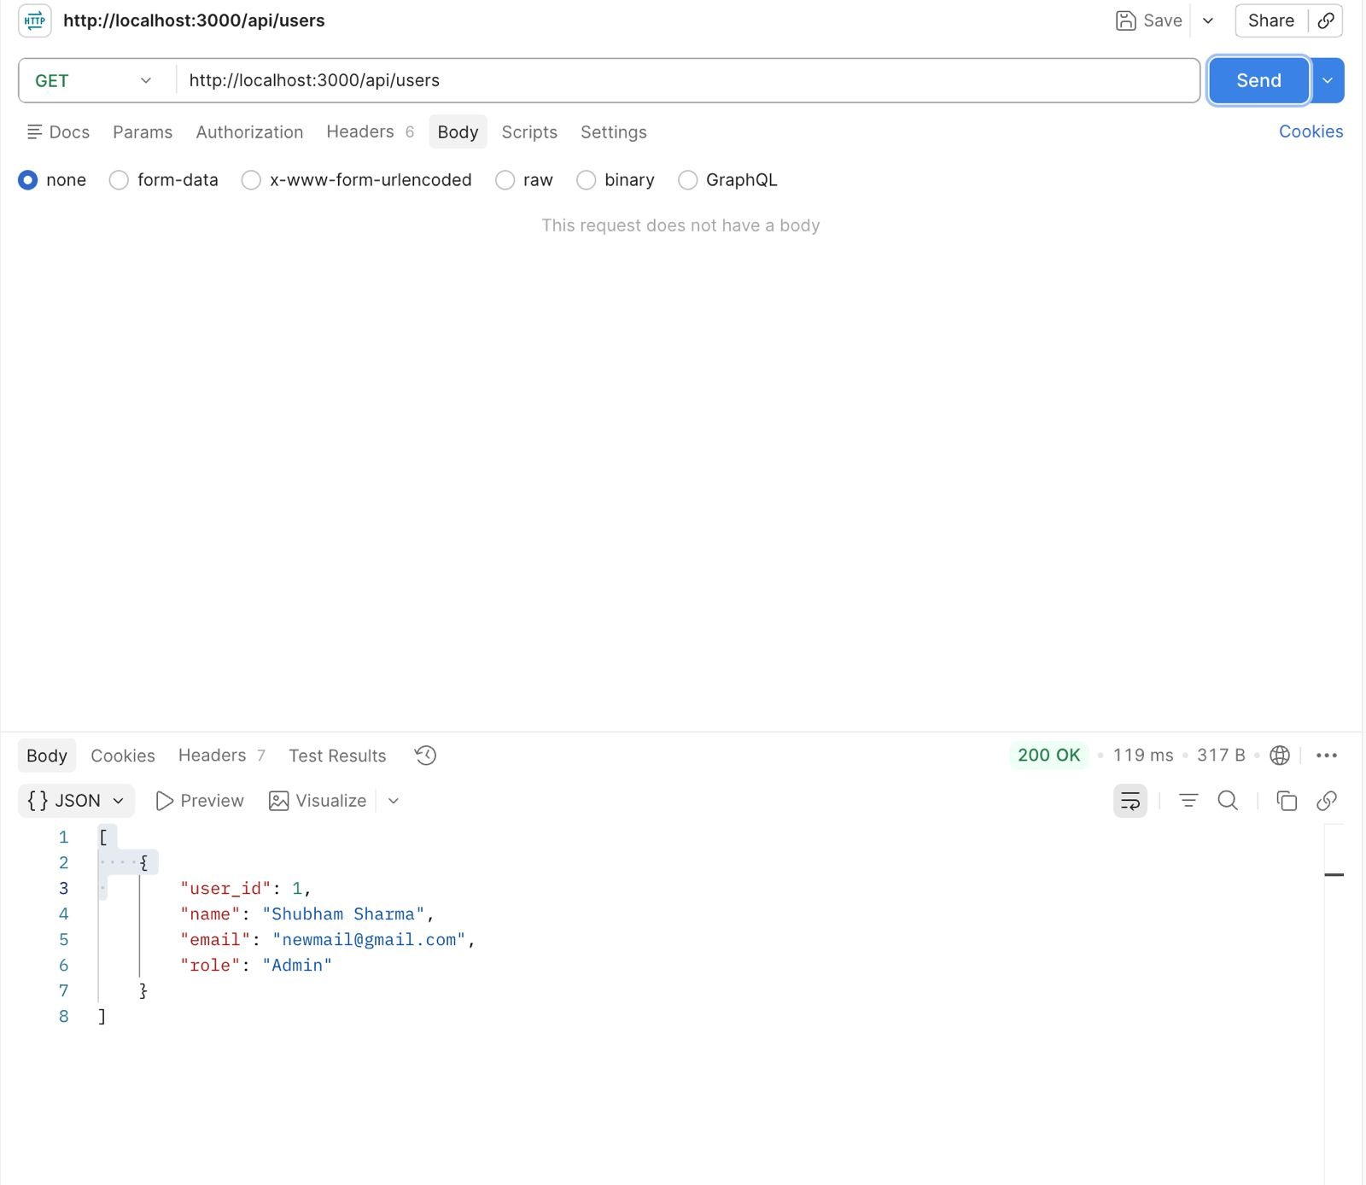
]

2.PUT api
URL—http://localhost:300/api/users/1
JSON file—[
{
“user_id” :1,
“Name”:”shubham”,
“Email”:”shubham@gmail.com",
“Role”:”admin”
}
]

Response-{
“Message:”user updated”
}

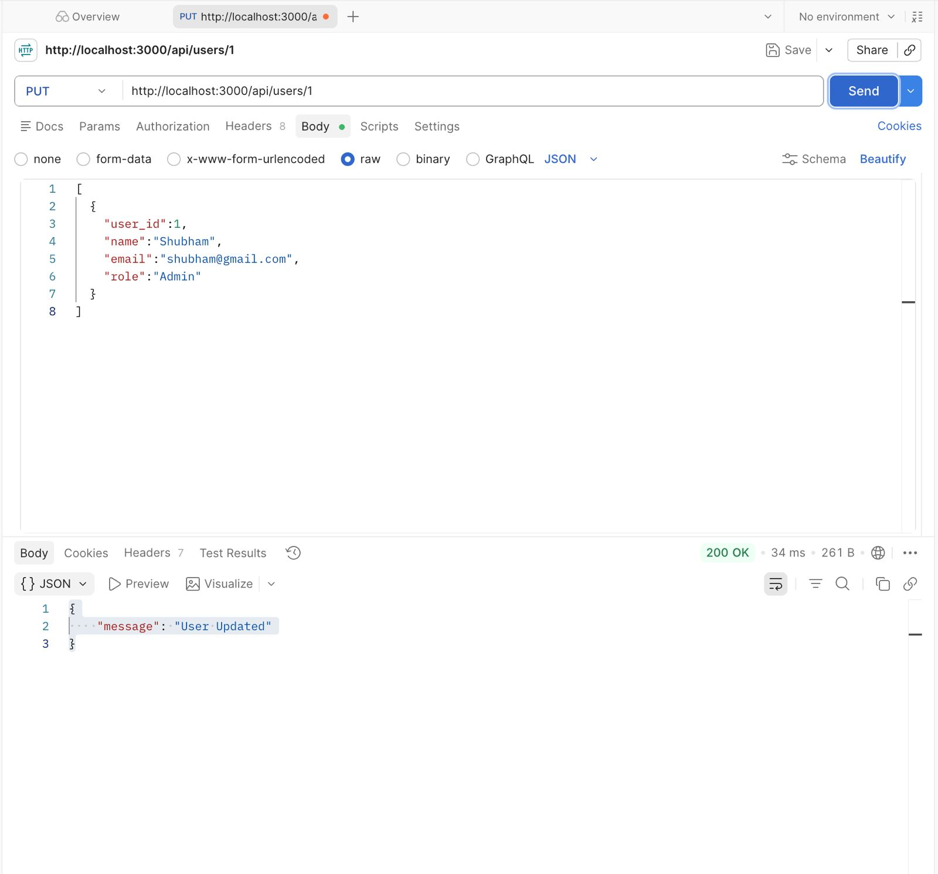

3.1.DELETE api
URL—http://localhost:3000/api/users/1
JSON file—{
“Name”: “test user”,
“Email”: “test@gmail.com",
“Role” : “employe”
}
Response—{
“Message” : “user deleted”
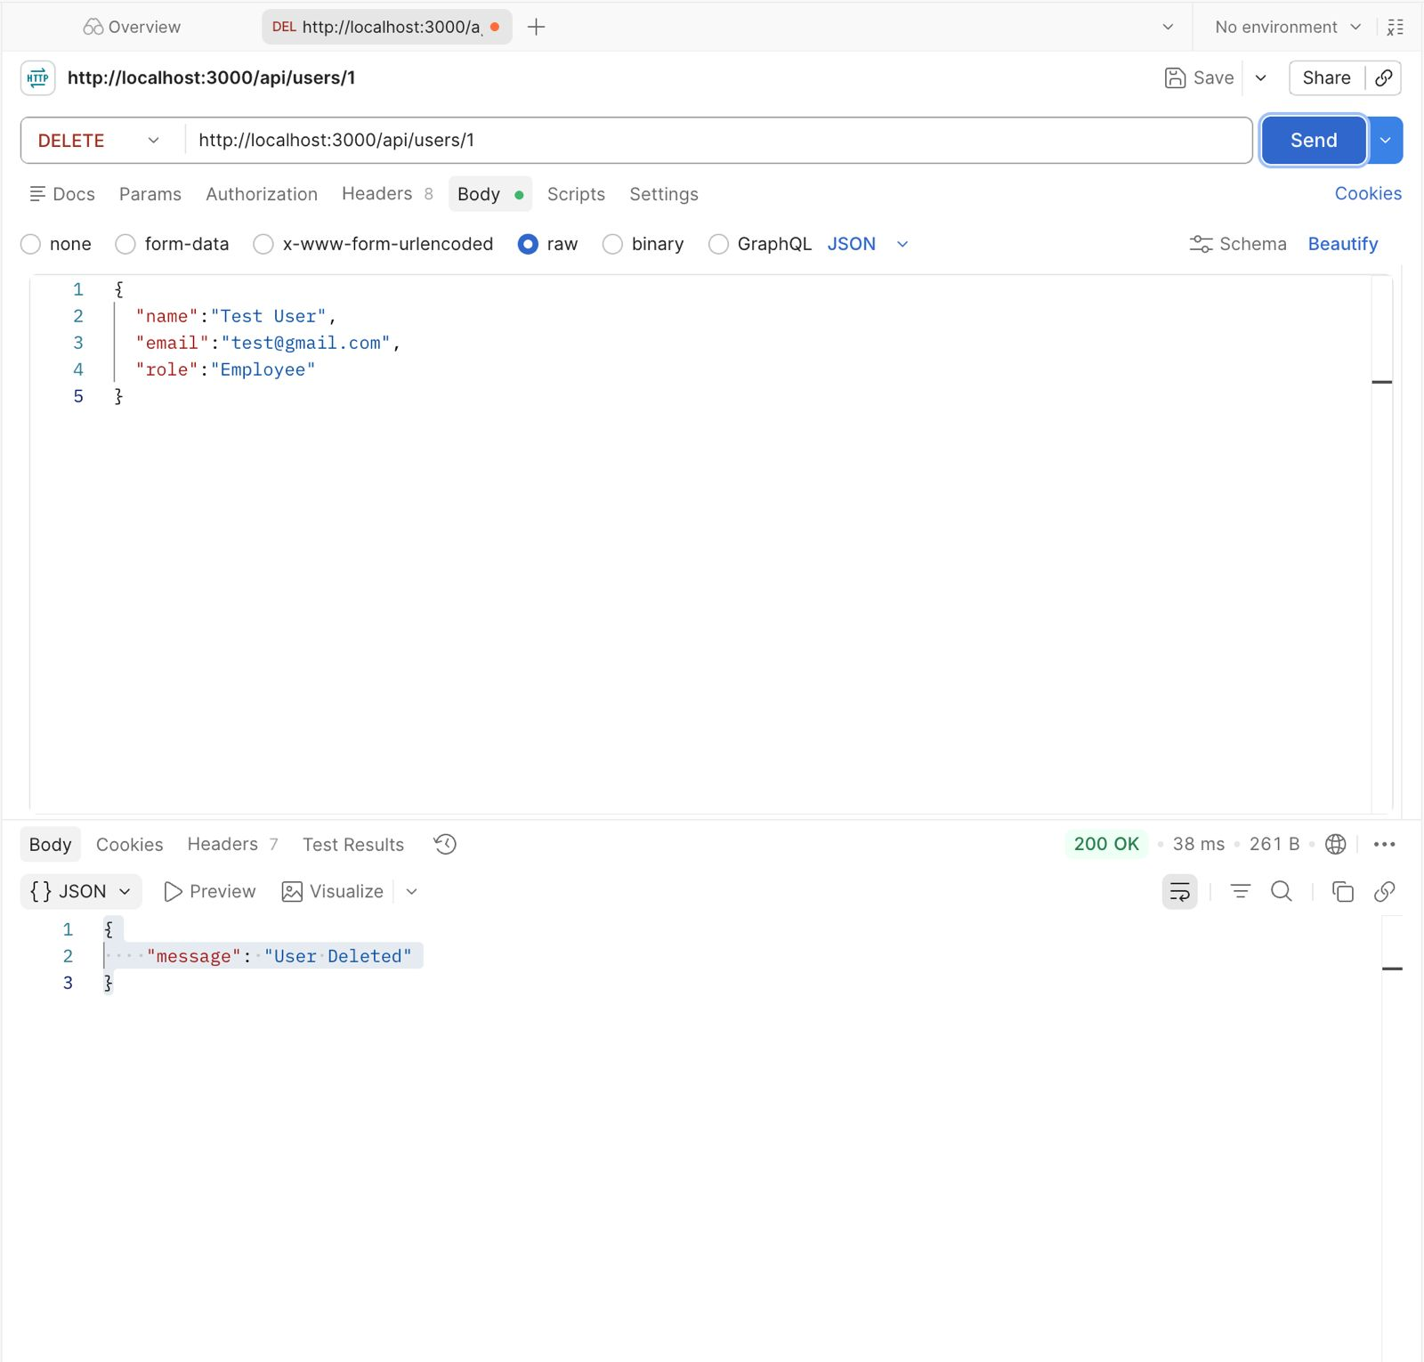
}

3.1.2DELETE api
URL—http://localhost:3000/api/users/2

JSON file—{
“Message” : “user deleted”
}
response—{
“Message” : “user deleted”
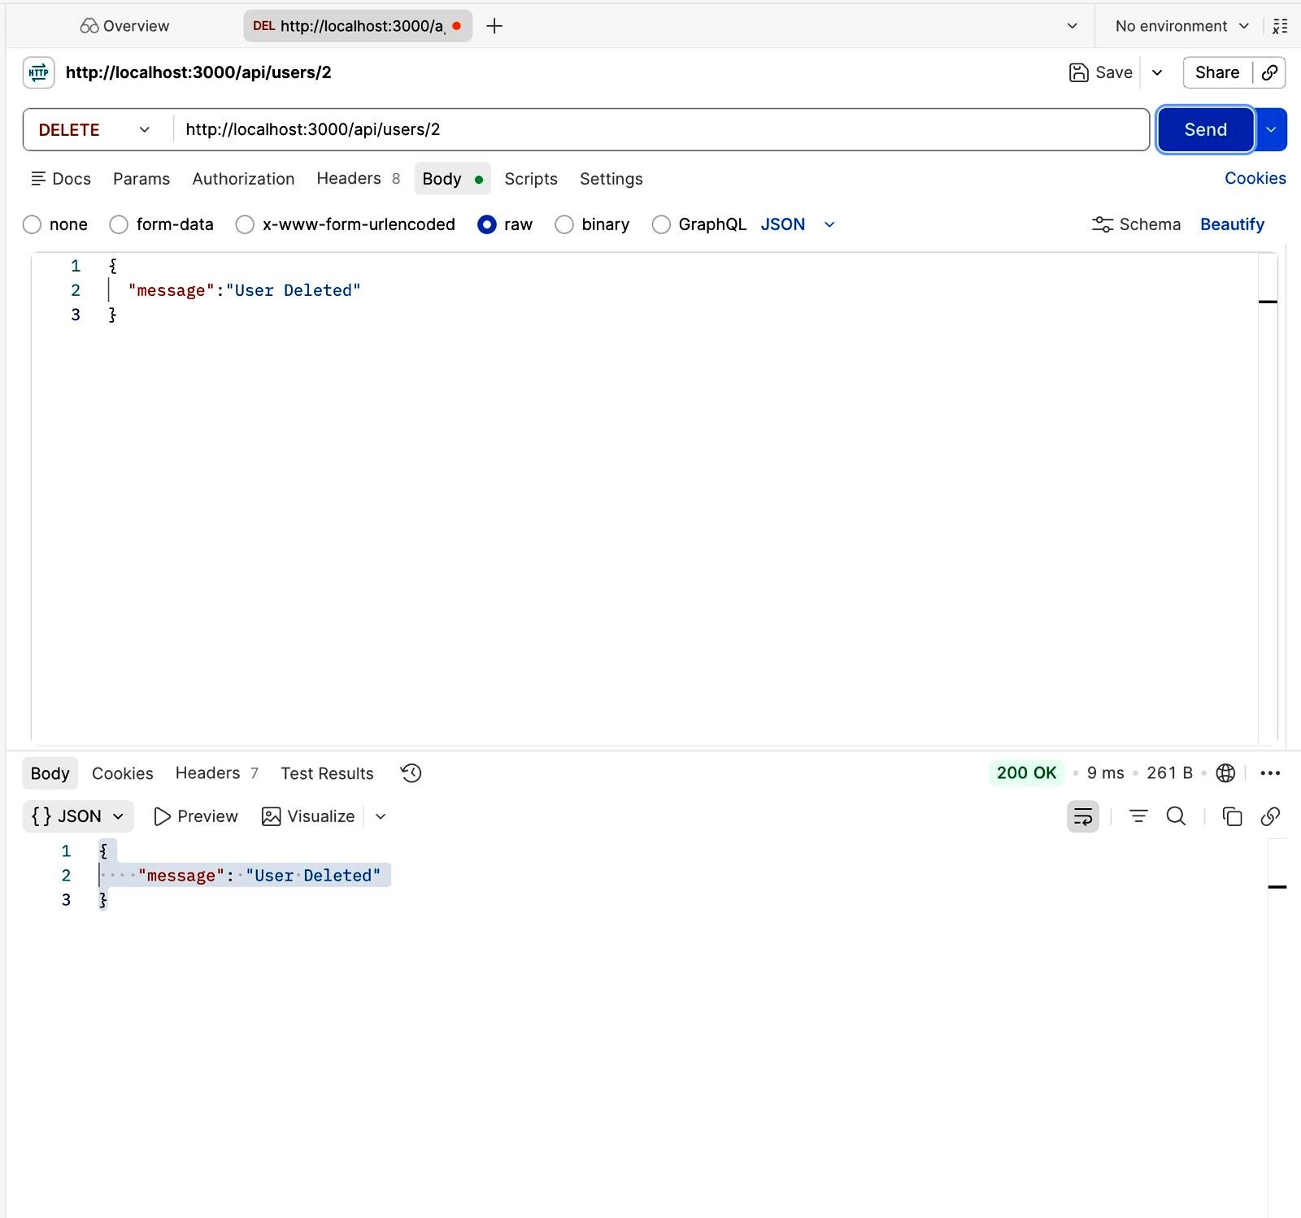
}
4.POST api
URL—http”//localhost:3000/api/incidents

JSON file—{
“incidentID” :1,
“Filename” : “phishing_email.png”,
“Description” : “screenshot of phishing email”,
“uploadedBY” : “shubham”
}
Response
{
"message": "User Created",
"id": 1
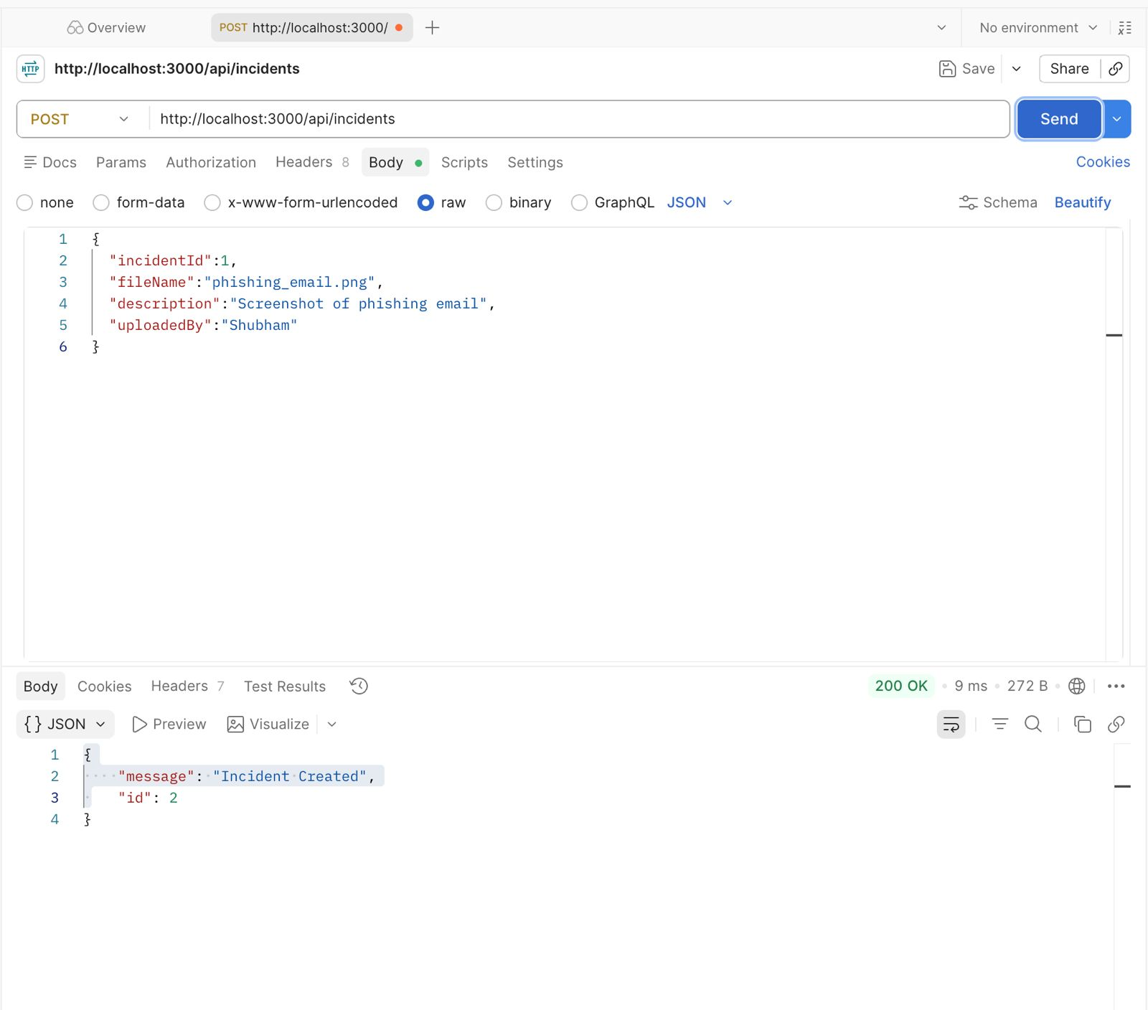
}

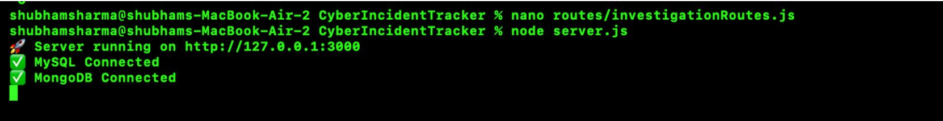
Terminal screenshot showing connections

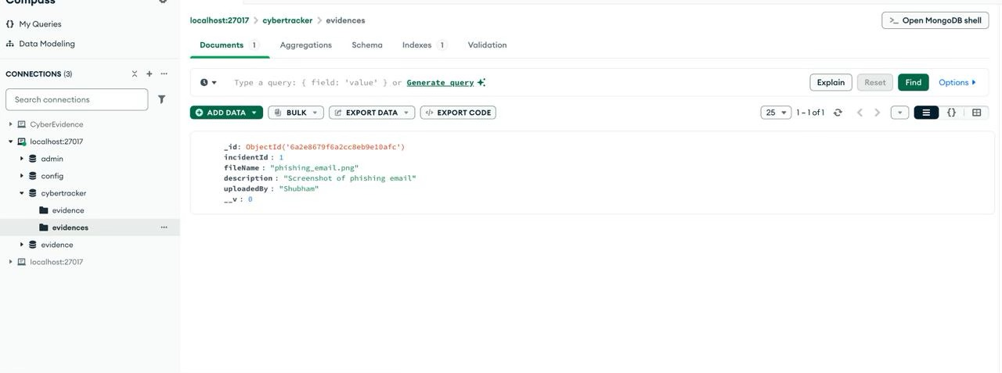
MongoDB compass screenshot
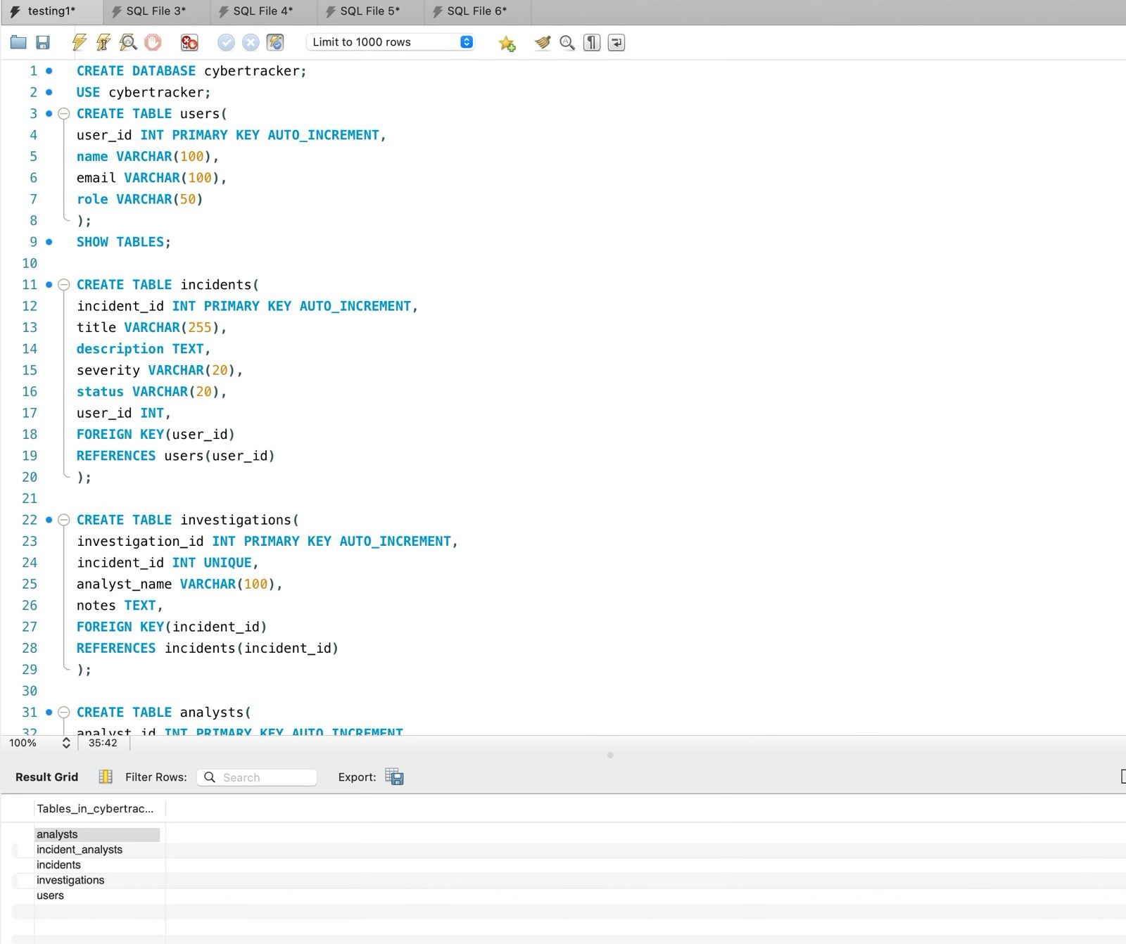
MySQL workbench screenshot

